CI/CD Pipeline Design Document
AI-Based Smart E-Waste Collection and Recycling Management Platform
CSA10 – Software Engineering | CO4 Assessment Tool 2 – CI/CD Pipeline Design Exercise

1. Requirement and Pipeline Analysis
The E-Waste Platform service is a containerized Node.js/Express API with a Jest/Supertest test suite, a Git Flow branching model (main, develop, feature/*, release/*, hotfix/*), and an existing Dockerfile and Docker Compose setup. A CI/CD pipeline is needed to automatically validate every change, enforce quality and security gates, and deploy consistently to development, staging, and production without manual, error-prone steps.
1.1 CI/CD Needs Identified
- Automatically run the existing Jest/Supertest suite on every push and pull request, so defects like the ones found during manual code review (Section 3 of the Code Review report) are caught before merge, not after.
- Enforce code-quality and security checks (linting, static analysis, dependency/container scanning) as required gates rather than optional developer habits.
- Build and version the Docker image automatically from the project's existing Dockerfile, tagged traceably to the triggering commit.
- Deploy automatically to a Development environment on every develop merge for fast feedback, and to Staging on release branches for pre-production validation.
- Gate Production deployment behind manual approval and automated health checks, with a defined rollback path.
- Notify the team immediately when any pipeline stage fails.
1.2 Mapping to the Existing Branching Strategy
The pipeline is designed to plug directly into the Git Flow model already established for this project: feature branches trigger the CI checks (build, test, quality, security) on pull requests into develop; develop deploys automatically to Development; release/* branches deploy to Staging; and main deploys to Production behind a manual approval gate. hotfix/* branches run the identical CI/CD path so emergency fixes receive the same quality bar as regular releases.
2. Pipeline Architecture and Workflow
The pipeline is implemented as a single GitHub Actions workflow (.github/workflows/ci-cd.yml) with six sequential stages — Source, Build, Test, Code Quality, Security, and Package — followed by three environment-specific deployment jobs. Figure 1 shows the Continuous Integration path from commit to a quality gate; Figure 2 continues into Continuous Delivery/Deployment across environments.
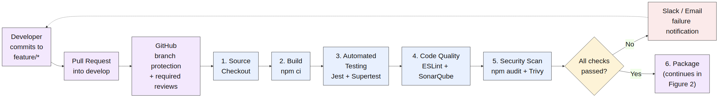
Figure 1: Continuous Integration stages — source through quality gate
Figure 2: Continuous Delivery/Deployment stages — package through monitoring/rollback
2.1 Workflow Explanation (Commit to Deployment)
- A developer commits to a feature/* branch and opens a pull request into develop; GitHub branch-protection rules require the pipeline to pass and a review to be approved before merge.
- On push, GitHub Actions checks out the source, installs dependencies with npm ci, and runs the Jest/Supertest suite with coverage reporting.
- If tests pass, ESLint and SonarQube analyze code quality, followed by npm audit and a Trivy scan for dependency and container vulnerabilities.
- If every check passes, the workflow builds the Docker image, tags it with the commit SHA and latest, and pushes it to GitHub Container Registry.
- Merging to develop automatically deploys the new image to the Development environment and runs a smoke test against /health.
- Pushing a release/* branch automatically deploys to Staging, where a fuller regression/E2E suite runs against a production-like setup.
- Promotion to Production requires manual approval from a release manager (enforced via a GitHub Environment protection rule), after which the workflow performs a blue-green deployment and a post-deploy health check.
- If the post-deploy health check fails, the workflow automatically switches traffic back to the previous (blue) version; either way, the outcome is reported to Monitoring/Alerting and the team is notified via Slack/Email if any stage failed.
3. Tools and Technology Selection
Each stage's tooling was chosen to reuse technology already present in the project wherever possible, minimizing new operational overhead.
Stage | Tool / Technology | Justification
Source Code Management | GitHub + Git Flow (main/develop/feature/release/hotfix) | Already in use for the project; branch protection rules and required reviews enforce quality before merge.
CI Orchestration | GitHub Actions | Natively integrated with the GitHub repository — no separate CI server to host or maintain; free tier is sufficient for this project's scale.
Build | Node.js 20 + npm ci | npm ci installs exact versions from package-lock.json, giving reproducible builds instead of npm install's potential version drift.
Automated Testing | Jest + Supertest | Already the project's test framework; Supertest allows HTTP-level integration testing of Express routes without a real network call.
Code Quality Analysis | ESLint + SonarQube | ESLint catches style/logic issues at commit time; SonarQube adds deeper static analysis (complexity, duplication, maintainability rating) with a quality-gate that can block merges.
Security Scanning | npm audit + Trivy | npm audit checks dependency vulnerabilities; Trivy scans both filesystem and the built container image for OS-level and library CVEs before it ships.
Packaging | Docker | The application is already containerized; building here reuses the existing Dockerfile and produces a single deployable artifact.
Image Registry | GitHub Container Registry (ghcr.io) | Integrates with the same GitHub authentication/permissions already used for the repository, avoiding a third registry account to manage.
Deployment Orchestration | Kubernetes (kubectl apply) | Matches the container architecture already designed for the platform; supports rolling and blue-green deployments natively.
Monitoring & Alerting | Prometheus + Grafana | Consistent with the monitoring stack already selected in the platform's architecture design (see Section 9, Deployment Architecture, of the earlier report).
Notifications | Slack / Email (GitHub Actions integrations) | Immediate visibility for the team when a stage fails, without needing to actively check the Actions dashboard.
4. Pipeline Configuration (GitHub Actions Workflow)
The following workflow definition implements the pipeline described above and was added to the project repository at .github/workflows/ci-cd.yml (commit 4b545c3).
name: CI/CD Pipeline - E-Waste Platform Service

on:
push:
branches: [main, develop, "release/**", "hotfix/**"]
pull_request:
branches: [main, develop]

jobs:
build-and-test:
steps:
- uses: actions/checkout@v4
- uses: actions/setup-node@v4
with: { node-version: "20", cache: "npm" }
- run: npm ci
- run: npm test -- --coverage

code-quality:
needs: build-and-test
steps:
- run: npx eslint src/ --format stylish
- uses: sonarsource/sonarqube-scan-action@v2
- run: npm audit --audit-level=high
- run: trivy fs --exit-code 1 --severity HIGH,CRITICAL .

package:
needs: code-quality
steps:
- uses: docker/login-action@v3
- run: docker build -t $REGISTRY/$IMAGE_NAME:${{ github.sha }} .
- run: docker push $REGISTRY/$IMAGE_NAME --all-tags

deploy-dev:
needs: package
if: github.ref == 'refs/heads/develop'
environment: development

deploy-staging:
needs: package
if: startsWith(github.ref, 'refs/heads/release/')
environment: staging

deploy-production:
needs: deploy-staging
if: github.ref == 'refs/heads/main'
environment: { name: production }
# Environment protection rule enforces manual approval

The full workflow file also includes smoke-test, blue-green switch, and automatic rollback steps for the deployment jobs, shown in Section 5.
5. Automated Testing Strategy
Testing is layered across the pipeline so that cheaper, faster checks run first and gate more expensive ones, giving developers quick feedback while still validating thoroughly before production.
Test Type | Tool | Runs At | Purpose
Unit Tests | Jest | build-and-test job, every push/PR | Verify individual functions (e.g., pickup.service.js) behave correctly in isolation.
Integration Tests | Jest + Supertest | build-and-test job, every push/PR | Verify Express routes and middleware work together correctly end-to-end within the app.
Static Code Analysis | ESLint, SonarQube | code-quality job, after tests pass | Catch style violations, code smells, and maintainability issues before they reach review.
Dependency Vulnerability Scan | npm audit | code-quality job | Detect known CVEs in third-party packages before they are packaged into a release.
Container Image Scan | Trivy | code-quality job | Detect OS-level and library vulnerabilities inside the built Docker image.
Smoke Testing | curl against /health | After deploy-dev and deploy-production | Confirm the newly deployed instance is up and responding before routing real traffic to it.
Regression / E2E Testing | Supertest / Postman collection | deploy-staging job | Exercise full pickup-scheduling workflows against a production-like environment before promotion.
6. Deployment Strategy and Environments
Three persistent environments (Development, Staging, Production) plus an expedited Hotfix path map directly onto the project's existing branching strategy, so the correct environment is always deployed automatically from the correct branch.
Environment | Trigger | Purpose | Approval Required?
Development | Automatic — every merge to develop | Fast feedback for the integration branch; used by developers to verify features together. | No
Staging | Automatic — every push to a release/* branch | Production-like environment for regression/E2E testing before a release is finalized. | No (tests must pass)
Production | Manual-gated — merge to main after staging passes | Serves real users; protected by a required-reviewer approval gate and blue-green deployment. | Yes — release manager
Hotfix | Automatic on hotfix/* → merges to main and develop | Emergency fixes bypass the full release branch but still run the full test/quality/security gates. | Yes — expedited approval
6.1 Production Deployment Approach — Blue-Green
Production deployment uses a blue-green strategy: the new version is deployed alongside the currently live version, verified with a health check, and traffic is switched only once the new version is confirmed healthy. This keeps the previous version running and ready, so rollback is a traffic switch rather than a redeploy.
7. Security, Quality Checks, Notifications, and Rollback
- Security: npm audit and Trivy scans run as required gates before any image is packaged, and production secrets (registry credentials, Kubernetes context) are stored as GitHub Encrypted Secrets rather than in the workflow file.
- Quality Gates: SonarQube's quality gate and ESLint must pass before the pipeline proceeds to packaging, preventing known-poor-quality code from ever reaching a deployable image.
- Access Control: the production environment is protected by a GitHub Environment protection rule requiring a designated release-manager approval, separate from the automatic approvals used for Development and Staging.
- Notifications: Slack/Email notifications fire on any stage failure, and a workflow-level status is visible on every pull request so failures are caught at review time, not after merge.
- Rollback Mechanism: the blue-green deployment step keeps the previous production version running; if the post-deploy health check fails, the pipeline automatically switches traffic back to the previous version without requiring a new deployment or manual intervention.
- Auditability: every deployment is traceable to an exact commit SHA via the Docker image tag, so any production issue can be matched back to the precise code and pipeline run that produced it.
8. Pipeline Execution Evidence
A representative pipeline run triggered by a push to develop is shown below, covering build/test, code quality, packaging, and development deployment.
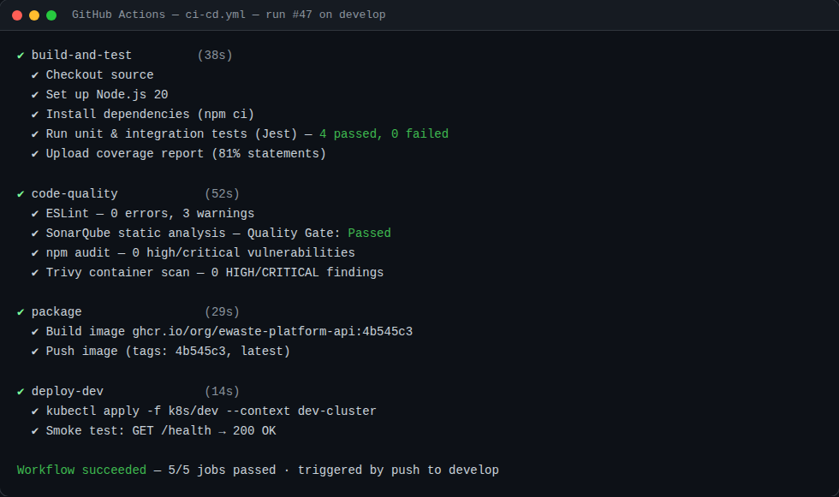
Screenshot 1: GitHub Actions run summary for the CI/CD pipeline (develop branch)
9. Summary
This CI/CD pipeline automates the full path from code commit to production deployment for the E-Waste Platform service: every change is built, tested, statically analyzed, and security-scanned before an image is ever produced; deployments flow automatically through Development and Staging, matching the project's existing Git Flow branches; and Production is protected by manual approval, blue-green deployment, and automatic rollback. Combined with the testing strategy defined in the accompanying Test Case Design document, this pipeline gives the project a repeatable, auditable path to reliably ship changes to the platform.

